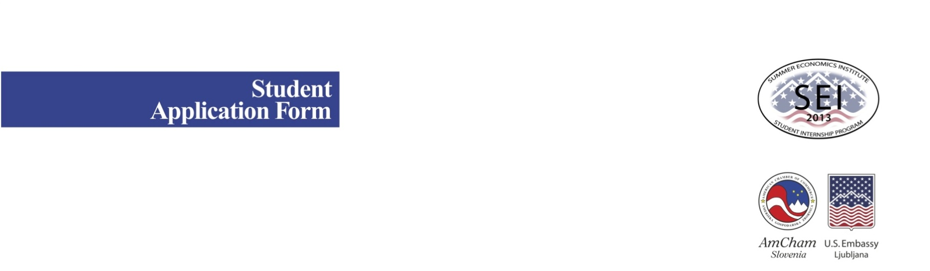

Personal Information

Name (First, Last):
Home Address:
City/Postal Code:
E-Mail:
Mobile Phone:
Date of Birth:
Country of Citizenship:
How did you hear about SEI?
(Be specific: your university, Facebook, Twitter, a friend, etc.)
School / Work / Leisure
University & Faculty
Current Year of Study:
Years University attended
(e.g. 2010-present):
Faculty Professor who will complete the Recommendation Form
(Name, Faculty, Phone, Email):
Average Grade*: |  | *(Please attach a scanned copy of your school transcript)
Study-Related Activities:
Honors, Awards:
Educational Plans:
Career Interests:
Previous Work Experience:

Non-university Activities
you participate in:
Hobbies:
Internship Skills and Interests
Internships may be available in the following areas. Please indicate your top three (3) choices:

 | Auditing/Accounting |  | Human Resources
 | Advertising/Marketing |  | Information Technology (IT)/Computers
 | Banking/Financial services |  | Journalism/Media
 | Communications/ |  | Law
 | Consulting |  | Manufacturing
 | Consumer goods/trade |  | Pharmaceuticals/Medical Supplies
 | Education |  | Public Relations
 | Energy |  | R&D
 | Engineering |  | Sales/Marketing
 | Food Industry |  | Tourism
 | Healthcare
Please describe your faculty courses and work experience, if any, which relate to your above choices:

Please tell why you are interested in working in the industry/industries indicated above and what you hope to gain from the SEI experience.

Essay/Creative Form of Expression
We are looking for not only outstanding students, but also those who exhibit creativity and imagination.
Either:
submit a one A4 page essay on how to make Slovenia a better place OR
submit a one A4 page description of a product or service that you would invent or think would make Slovenia a better place OR
send us a video link with your invention, musical composition, or other creative form of expression that will tell us something about yourself (you must be in the video; video length max. 15 min, you must introduce yourself and your topic in English).
Languages

Please list the language(s) that you speak:

Important Information
Please read carefully

Minimum 3rd year students can apply, who hold their student status at least till the end of August 2013. SEI 2013 will take place 1st- 31th July, five days per week. Beside Monday's seminar with lectures, field work etc. where high level of English is required, students are also expected to fulfill the one month 128 working hour norm at the given company. Perfect atten-dance is expected on all class and workdays except in the case of illness or emergency. Student might get a small stipend (depends on the company) but they will not receive any compensation or other benefits from the employer itself. We cannot guarantee placements at specific companies nevertheless will try to match interns with sponsoring businesses in their field of interest.
Housing as well as transportation to and from internship and to and from classes in Ljubljana are responsibility of the student. SEI will provide transportation to and from any field trips, visits, etc. that are deemed part of the program.
English will be required for the coursework portion of the internship and may be used at the company student intern with. Therefore, student must be able to write and speak English on a high level. His/her written English will be evaluated from his/her written application and essay, and spoken English will be verified at the interview.

I understand and agree to all the provisions set forth above.

Additional Information

Applications are due by May 10th, 2013.
Interviews for top applicants will be held at May 28/29th, 2013.
Applicants will be notified of acceptance at the beginning of June 2013.

Your application must include:
- this completed form (in English)
- your essay/form of creative expression (in English)
- a copy of your transcript with information on all of your passed exams and grades for each year at the faculty
(in Slovene)
- your recent photo in jpg file

Please remember that applications cannot be considered without a professor’s recommendation. So, please make sure your professor fills out the special “Professor Recommendation form” and sends it to katarina.makovec@amcham.si For practical reasons we recommend sending both filled-in forms (this application form as well as Professor Recommendation Form) including student essay/form of creative expression, his/her trancript and his/her photo in jpg file together in just one e-mail.

If you cannot e-mail the application for some reason, please mail it by post to:

American Chamber of Commerce
AmCham Slovenia
Summer Economics Institute (SEI)
Dunajska 156
1000 Ljubljana
Slovenia

For any further information please contact:
Katarina Makovec
AmCham Slovenia SEI project manager at
katarina.makovec@amcham.si
phone: + 386 40 766 999

