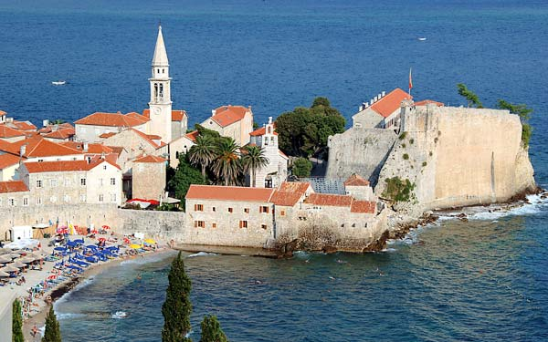

8-21 September 2013

Budva/Montenegro

Application Form& Application for Admission

To be delivered by e-mail until 23 June 2013!

Personal Data
Sex |  | Academic Degrees
First Name
Last Name
Home Address (Street, Street no., Postal Code, Country)

Postal Address for Correspondence (Only if different from home address! Street, Street no., Postal Code, Country)

Email |  | Phone/Fax
Date/ Place of Birth
Nationality |  | Passport Number
Social Insurance Number
Education
University (Name and Country)
Field of study
Degrees (obtained or expected)
List of courses and practical experience in democratisation and human rights

Languages
Do you consider your knowledge of English to be at a sufficient level for attending courses on democracy and human rights thought in English? List from 1 (excellent) to 5 (weak)
For actively taking part in the discussion  For understanding lectures  For reading texts  For writing a paper |  | From 1 to 5
 |  | From 1 to 5
 |  | From 1 to 5
 |  | From 1 to 5
How did you learn about the Straniak Academy?
Application
I hereby apply for the Straniac Academy on Democracy and Human Rights which will take place during the 2nd and 3rd week of September 2013 (8 September 2013 - 21 September 2013) in Budva, Montenegro.

The tuition fee for the Straniak Academy on Democracy and Human Rights is EUR 75 for participants from Southeast European States (Albania, Bosnia and Herzegovina, Croatia, FYROM, Montenegro, Serbia and Kosovo) and EUR 150 from EU Member States and all other States around the world.

Accommodation (bed and breakfast) is covered by the Straniak Academy. Travel and subsistence expenses are not covered by the tuition fee and must be borne by the applicants. All bank charges incurred for remitting the tuition fee are borne by the applicant.

The number of places is limited (30). Admission to the Straniak Academy is subject to available places and the applicant’s qualification which will be considered by the Selection Committee of the Straniak Academy.

The cancellation of the application has to be submitted in writing no later than 4 weeks before the start of the Straniak Academy. The cancellation fee amounts to 30% of the tuition fee. If an application is not cancelled in due time, the cancellation fee amounts to 100% of the tuition fee.

Please attach copies of the following documents to this application form: | Please, sign this form, and send your complete application by e-mail simultaneously to:
- Letter of motivation  - CV  - Academic transcripts or Student ID  - Optional: letters of recommendation  The Academy’s team is:  Prof. Hannes Tretter, Director  Prof. Ivana Jelić, Deputy-director  MMag. Nina Radović, Coordinator | hannes.tretter@univie.ac.at  ijelic@yahoo.com nina.radovic@humanrights.at  Ludwig Boltzmann Institute of Human Rights  Freyung 6/2/4  A – 1010 Vienna  Tel. +43 1 4277 27420  Fax +43 1 4277 27429  Webpage: http://bim.lbg.ac.at/en
I hereby agree that my data can be stored electronically for the purpose of application and I will receive mail for information purposes. I have the right to objet to such mail at any time. My data will not be disclosed to any third party.
Date, Place | Signature

