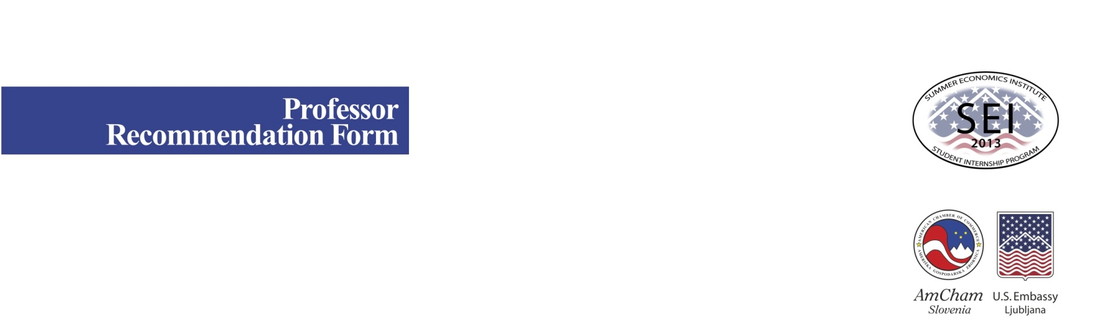
Name (Title, First, Last):
University & Faculty:
Field of Expertise:
Subject(s) taught:
E-mail: | mmmmmmmmmmmmmmmmmmmmmmmmmmmmmmmmmmmmmmmmmmmmmmmmmmm
Mobile Phone:
How long have you known the applicant?
In what capacity?
(Professor, Thesis Mentor, etc.)
Student’s name (First, Last):
University & Faculty:
Year of Study:
Courses/Subject(s) she/he
attends/completed with you:
:

Evaluation of Student

Please write a short recommendation of the student below, preferably in English (although Slovene is also acceptable).
Please include:

- His/her grades in your class(es), as well as comments on his/her class participation (strong/weak participant)
- His/her ranking in your class (e.g. top of the class, middle, bottom)
- If you are/were the mentor for the senior thesis: please give an evaluation of the thesis work overall to date (work habits of student, originality of thought/inventiveness, execution of thesis work, writing ability, etc.)
- Extracurricular activities: if the student worked with you on activities outside of the classroom please include mention them.
- General description of student: if you know the student well we would also appreciate your insights into his/her leadership ability, your overall feeling of him/her as a person, and his/her creativity, etc.
- If this student has not shown strong academic talent, but has shown his/her talents in other ways that you think are promising, please tell us about them.

Your recommendation here:

Thank you for your assistance in this application to the Summer Economics Institute. Your comments will be held in strict confidence.

Please e-mail this form to katarina.makovec@amcham.si with “SEI Professor Recommendation: (Name of Student)” in the subject line at latest by May 10th, 2013. For practical reasons we recommend sending both filled-in forms (this Professor Recommendation Form as well as Student Application Form) including student essay/form of creative expression his/hers trancript and his/her photo in jpg file together in just one e-mail.

If you cannot e-mail the application for some reason, please mail it by post to:

American Chamber of Commerce

AmCham Slovenia
Summer Economics Institute (SEI)
Dunajska 156
1000 Ljubljana
Slovenia

For any further information please contact:
Katarina Makovec
AmCham Slovenia SEI project manager at
katarina.makovec@amcham.si
phone: + 386 40 766 999

